

The online game website I research is Desura. Desura is released in 2009 by an Austrialian games company and was in stealth development for 2 years. For that reason, Desura is still quite new to the game world and a lot of people still do not know about it. So it is not as popular as now trending online game store such as Steam and Origin.

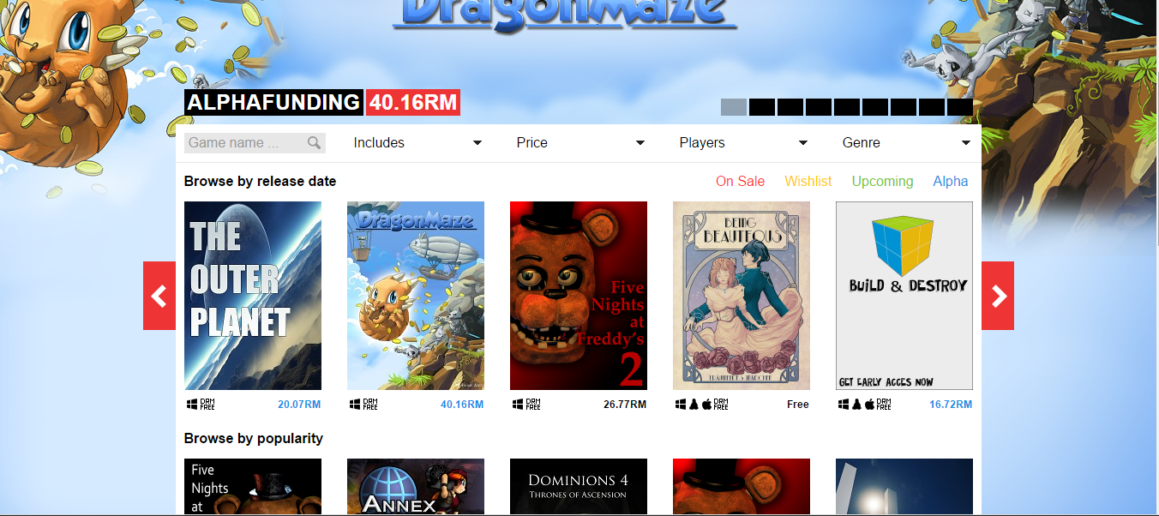

The good things about Desura is that its user-friendly and it has a very good design as shown above. They advertise the latest game as the background, and categorize the game on their home page, which gave user a good first starting impression, instead of some homepage packed with information that most buyers are lazy to even bother.

The website also support individual made game in short Indie game. Indie game mean anyone could sign up and sell their own made game on the website provided that if they did not break any rules. Desura also support the game in Alpha, mean the game that is working in progress (WIP) that is currently developing and haven’t even not playable as the content is too little. They also allowed developer to apply for Alpha funding for their developing game.

Next, the developers have control of their own games. Which also mean they need to manage the games they sell on the website themselves, by controlling the game price, marketing material and new articles of their games. This could mean troublesome to developer that working alone, but it is also better as they as the developer, know better of their game. They will need approval for new updates for their game and other things but according to research, the page admin did their job well and diligently. Most question or approval gets their result within one week.

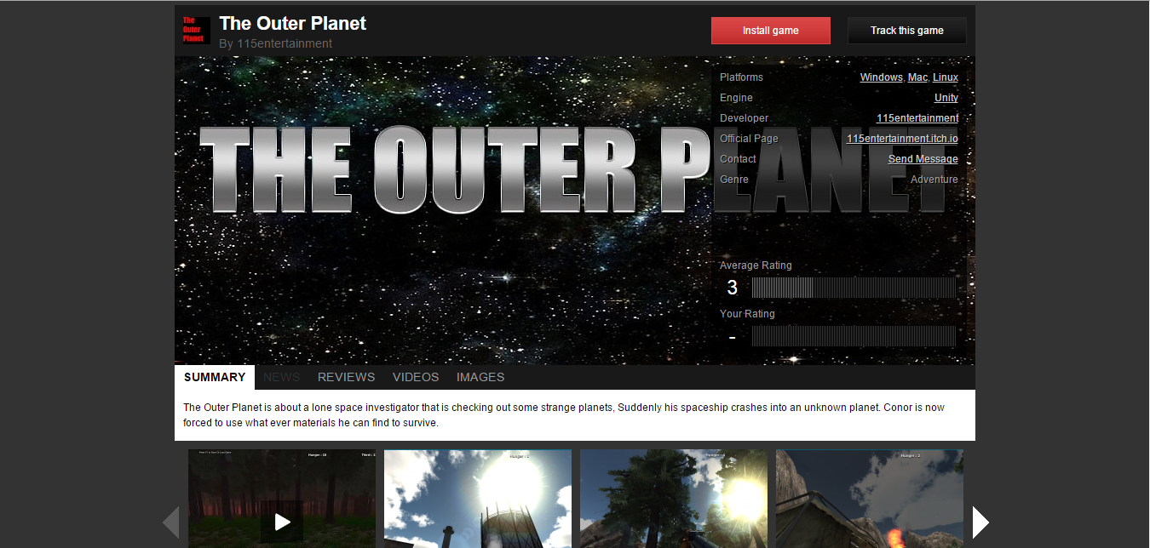

Notice from the image above, there are rating, platform for the game and contact of developer. People that want to know more about the game could click into the game and went into some page like above, the page of the game. You could contact the developer for any new idea, error bug, or want to know more information easily by clicking the send message to the developer. There are user rating, comment, picture and video too that user could check if the game suit their taste or not.

Three are a lot of good things about the webpage, but most trending webpage strike toward perfection so most of their advantage are almost same. But how about disadvantage of the website? Nothing is perfect, there are always something that someone disagree, or we as a human miss. But, opinions and suggestion make the things more perfect, so here is what I found out of the webpage that could be better.

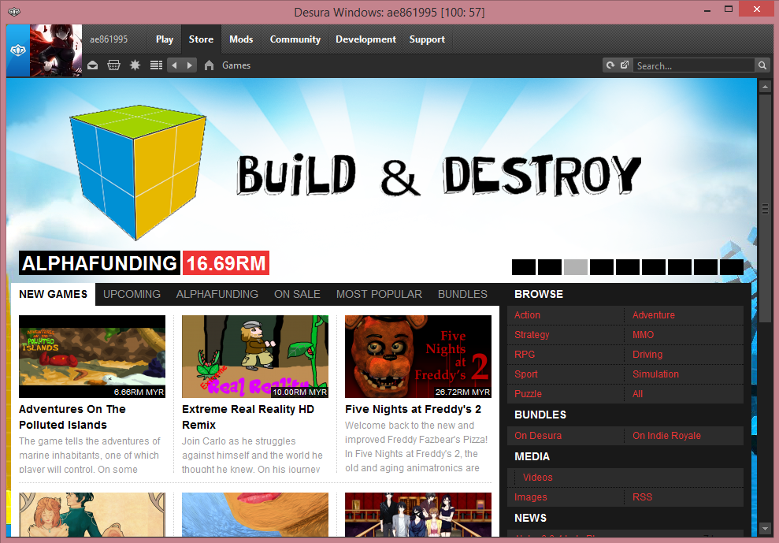

The gamers or buyers must have Desura client install to play the games they bought. Developers does not need to install the client though, they could register their game directly at the website. By having to install the client both have their own disadvantage and advantage but let talk about disadvantage. First it is troublesome to have to install the client and set them up, then learn and get used to it after clicking around and already used to their design on their webpage. Although their design is almost same, their webpage is a lot convenient and easier to use.

Next, the one thing I found is although they stated what the game is available on and for which and what version of window is the game for, but there are still some window that cannot run them. Some of the game is only available for window 32bit but not yet for 64bit, so when I try to run some games although my window is compatibility, they still crash and got error as window 64bit lack some of the window 32bit things.

Lastly, the one thing that is both disadvantage and advantage is that the games could only be bought digitally. So advantage is they are convenient, easy and save time but there are disadvantage too. Imagine if you got bad connection and you want to play the game so bad, but you are not available to download them as your internet speed is slow, you could not play the game even after you bought them. Or after u lost your account, you lost almost everything provided that you could not get back your account as you cannot proof it is yours.

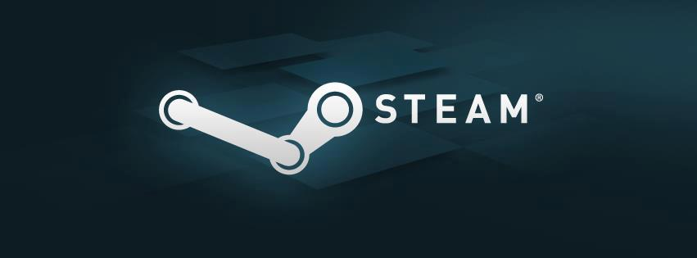

**STEAM**

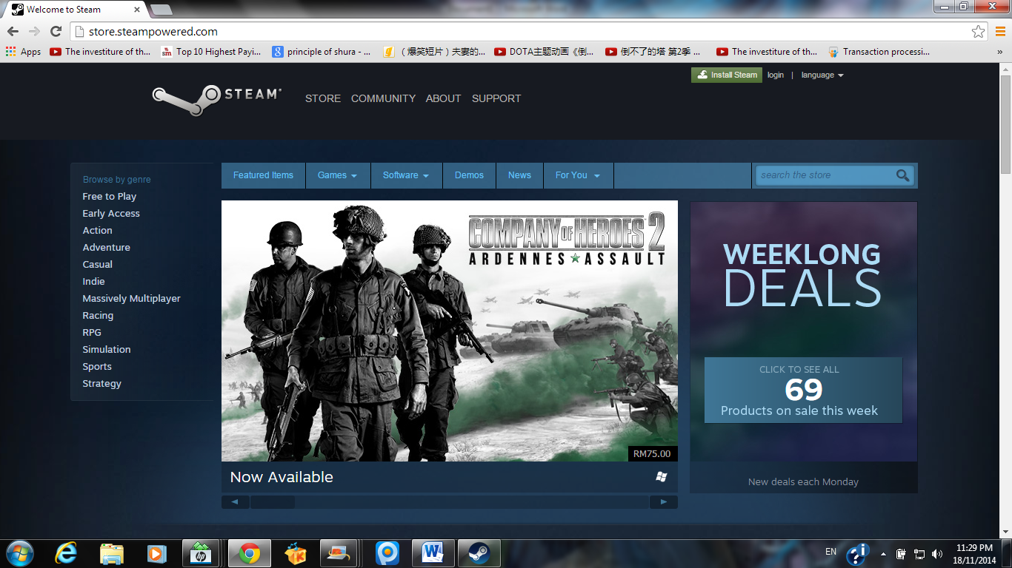

Steam is one of the game stores that I search. Steam is an internet-based digital distribution, digital rights management, multiplayer, and social networking platform developed by Valve Corporation. Steam provides the user with installation and automatic updating of games on multiple computers as well as community features such as friends lists and groups, cloud saving, and in-game voice and chat functionality.

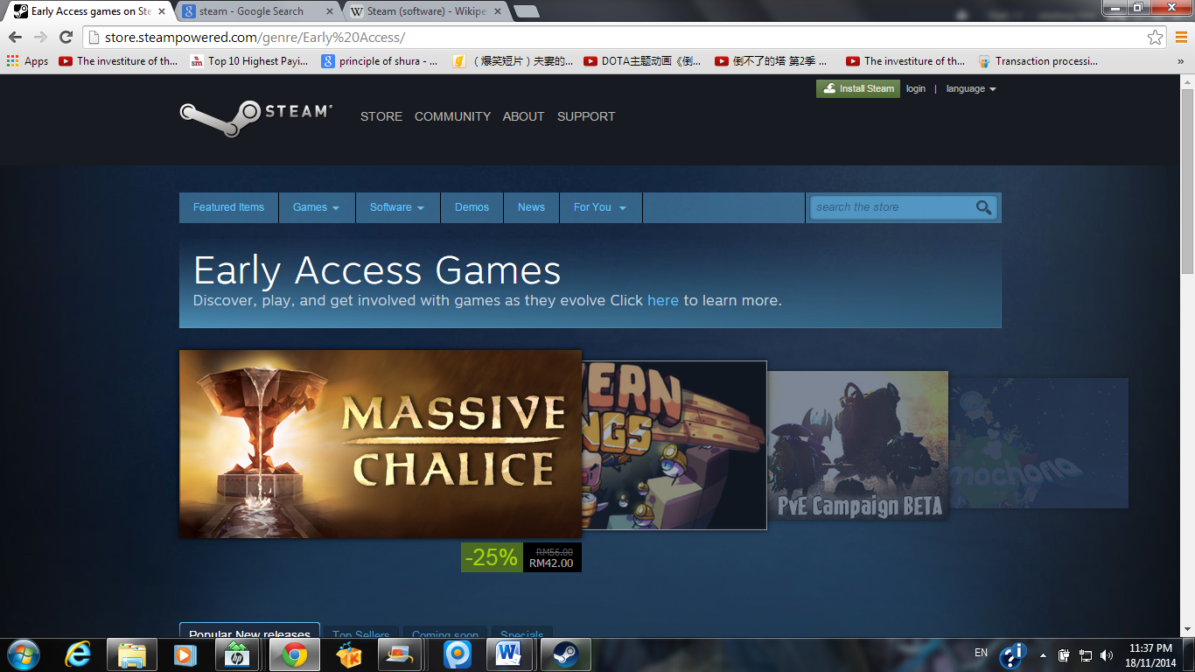

In the steam, there have a page about the early access games. Early access is can Get immediate access to games that are being developed with the community's involvement. These are games that evolve as you play them, as you give feedback, and as the developers update and add content.

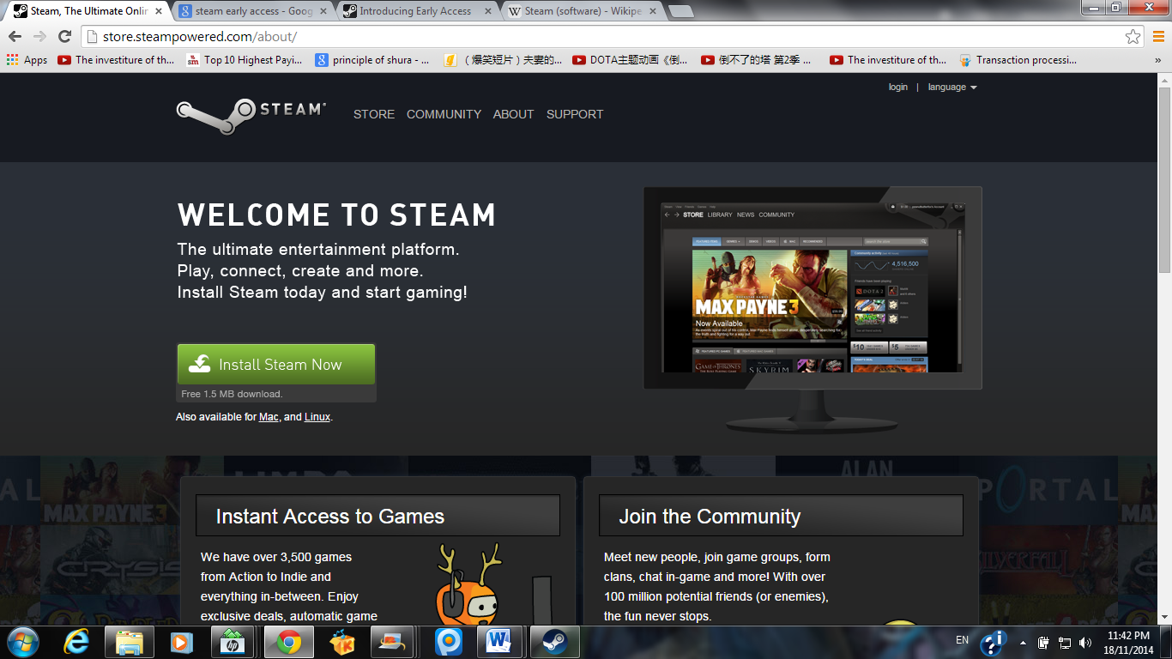

All the user or gamer that want to buy games or play games at steam, they need to install the steam client. After complete steam client, they need to register become the member of the steam. So that, they can buy games, play games and download games by using the steam client. After that, when user need to open their own id at others PC, they need to get the access code to login their own id and the access code will send to the user’s e-mail.

**Advantages of steam**

* **System requirements of the games**

When users want to buy games in steam, they can see the game’s system requirements, so that users won’t buy the games that not suitable for their pc.

* **Sharing access key**

When users brought a game, they will get the access key for the game. Users can share their access key with their friends.

* **Promotions for the games**

Steam always makes some promotions for some kind of games, so users can buy some games with discount.

* **Easy to find the games that u want**

During users search the games, they can tick the type of games that u want such as action, RPG, adventure and so on.

* **Automatic update for your games**

If some of your games have the latest version, steam will help u automatic update all your games that requirement update after you log in in steam.

**Disadvantages of steam**

* **Don’t have any contact information of steam in steam client**

If users can’t login their steam id without any reasons, they can’t contact to steam ask for help as there have no any contact information of steam in steam client or websites, so users very difficult to ask for help.

* **Steam id gone same as all the games gone**

If users lost their steam id or their id was hacked by hacker, they will totally lost their all the games that they purchase. Because the games that user downloaded will store in the user’s steam id in steam client and they can’t download the installer of the game and save in their pc.



**BEAMDOG**

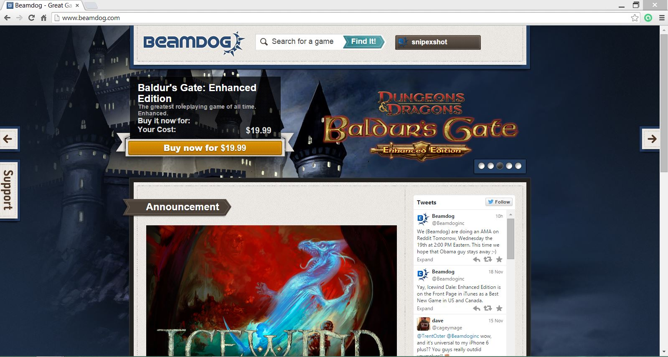 Beamdog is a game developer and distributor. It was founded in 2009 in Edmonton, Alberta, Canada.

The image above is the homepage for Beamdog website. same as other website, Beamdog provides a client for downloading installation for game that are purchased by the user and also for free update for the game.

On the main homepage of beamdog website, there are a section that are link to twitter that will show any tweets which are tweet by beamdog and also by user about beamdog. It can be say as a platform for the buyer and the admin of beamdog to communicate.

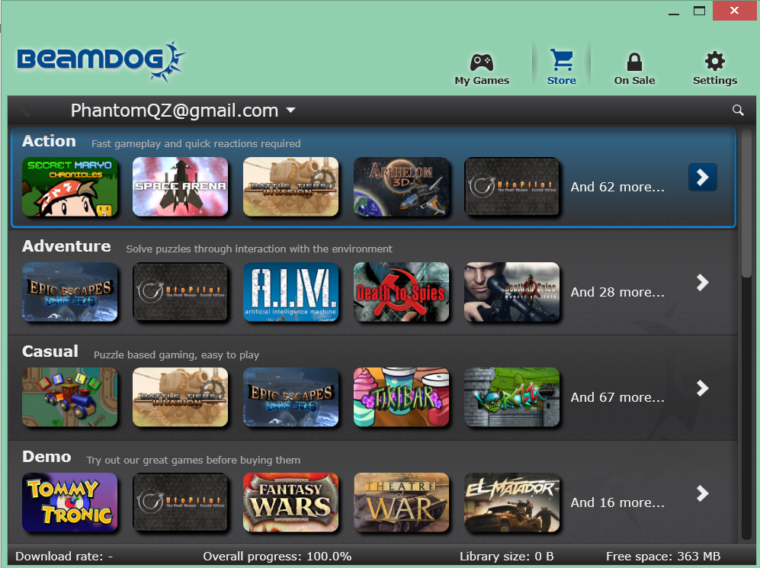

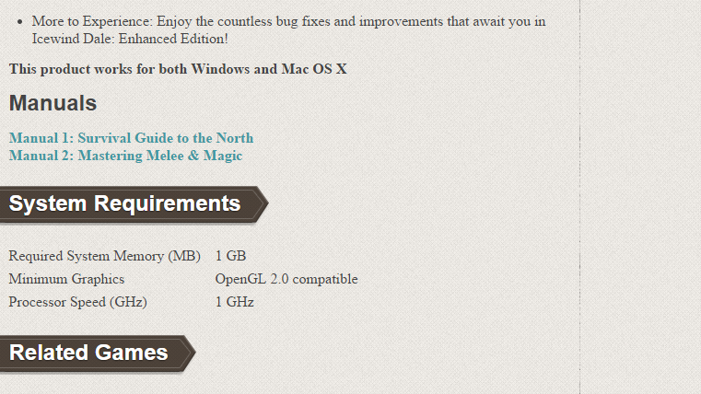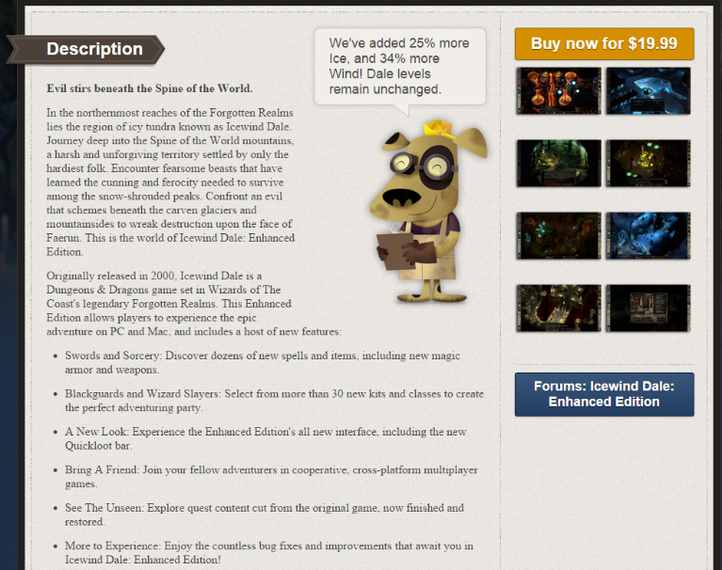 The client of Beamdog has link that will link the user to the webpage of the game with description, screenshot, link to forum, purchasing the game and also requirement of the game.

Pros:

* Price of the product is set by the developer.
  + Usually on other website after the game is develop and is on sale, the website set a price for the game and after sale a certain percentage of income earn by the sale is return to the developer, but for beamdog the price is fully depends on the developer to set it.
* Release date of the game is fully controlled by the developer
  + The release date of the game including alpha, beta, until the final version of the game is release is fully depends and controlled by the developer.
  + Usually on other website when they are working together with the developer, they will give the developer the timeline on what to do and when should the game is to be released.
* Has a very active forums
  + The link to the forum of the game is provided at the game description page and based on my survey, the forum provided by beamdog is very active.
  + The forum includes a lot of update, comment and also mods that are provide by other gamer.

Cons:

* Gamers must download client in order to download the game
* The description for the game is not very clear
  + The description that are written in the description column is mainly like a teaser or the storyline of the game.
* Hard to surf for game on the website, only provided search bar at the website.
  + Only provided filter by price and by publisher



aWhaaan uaers